Papa Corey_CMFS150M__FCS
Coriolis Flowmeter Calculation Summary |  |  |  |  |  | Quote/Rev No: |  |  |  | -/-
Date: |  |  |  | ‭2023-03-30‬
Company: |  |  |  | -
Project Name: |  |  |  | -
Service: |  |  |  | -
Sensor Model Name : |  |  |  | CMFS150M
Sensor Model #: |  |  |  | -
Sizing Name: |  |  |  | Papa Corey
Transmitter Model Name : |  |  |  | -
Transmitter Model #: |  |  |  | -
Transmitter Tag(s): |  |  |  | -
Wetted Material: |  |  |  | 316L
Fluid: |  |  |  | GULF COAST NATURAL GAS
Fluid State: |  |  |  | Gas
K(Flow Consistency Index) |  |  |  | -
n(Flow Behavior) |  |  |  | -
Mass Flow Accuracy (+/- % of Rate) |  |  |  | 00.2500
Pressure Drop at Operating Flow |  |  |  | 5.0043 | psig
Velocity at Operating Flow |  |  |  | 81.8891 | m/sec
 |  |  |  | Min | Operating* |  |  | Max |  |  | Design |  | Units
Flow Rate: |  |  |  | 300.0000 | 1500.0000 |  |  | 2000.0000 |  |  | - |  | kg/hr
Pressure: |  |  |  | - | 150.0000 |  |  | - |  |  | - |  | psig
Process Fluid Temperature: |  |  |  | - | 50.0000 |  |  | - |  |  | - |  | F
Ambient Temperature: |  |  |  | - | 68.0000 |  |  | - |  |  | - |  | F
Density: |  |  |  | - | 0.5192 |  |  | - |  |  | 0.0000 |  | lb/ft3
Viscosity: |  |  |  | - | 0.0103 |  |  | - |  |  | - |  | cP
Gas Only | Base Reference Temperature: |  | F | 60.0000
Gas Only | Base Reference Pressure: |  | psia | 14.6960
Gas Only | Base Reference Density: |  | lb/ft3 | 0.0440
Process Connection: |  |  |  | -
Process Connection Pressure Rating: |  |  |  | -
@Temperature: |  |  |  | 50.0000 F
Flow Rate | kg/hr | Mass Flow Accuracy (+/- % of Rate) |  | Pressure Drop* | psig |  | Velocity at Operating Flow |  | m/sec |  |  | Re
2000.0000 |  | 00.2500 |  | 8.8247 |  |  | 109.1855 |  |  |  |  | 1745231.2484
1830.0000 |  | 00.2500 |  | 7.4056 |  |  | 99.9047 |  |  |  |  | 1596886.5923
1660.0000 |  | 00.2500 |  | 6.1102 |  |  | 90.6239 |  |  |  |  | 1448541.9361
1500.0000 |  | 00.2500 |  | 5.0043 |  |  | 81.8891 |  |  |  |  | 1308923.4363
1320.0000 |  | 00.2500 |  | 3.8913 |  |  | 72.0624 |  |  |  |  | 1151852.6239
1150.0000 |  | 00.2500 |  | 2.9678 |  |  | 62.7816 |  |  |  |  | 1003507.9678
980.0000 |  | 00.2500 |  | 2.1683 |  |  | 53.5009 |  |  |  |  | 855163.3117
810.0000 |  | 00.2500 |  | 1.4932 |  |  | 44.2201 |  |  |  |  | 706818.6556
640.0000 |  | 00.2500 |  | 0.9425 |  |  | 34.9393 |  |  |  |  | 558473.9995
470.0000 |  | 00.2500 |  | 0.5167 |  |  | 25.6586 |  |  |  |  | 410129.3434
300.0000 |  | 0.2715 |  | 0.2165 |  |  | 16.3778 |  |  |  |  | 261784.6873
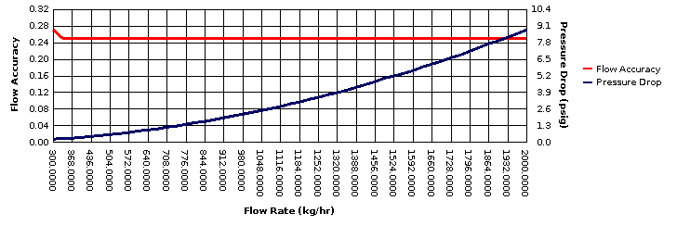
* All pressure drop and velocity results are based on the process conditions (except flow rate) that are entered in the Operating column.

